LA FECHA | TAREAS – CLASE | TAREAS – CASA
lunes  23 de febrero   | - Bienvendio  - Introduce Commands  - Watch Senior Jordan: Affirmative TU commands  - Turn in video notes by the end of class. | No hay tarea
martes  24 de febrero  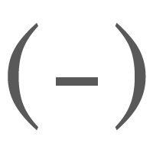 | - Bienvenido  - Anuncios  - Watch Senior Jordan: Negative TU commands  - Video worksheet is due at the end of class. | No hay tarea
miércoles  25 de febrero  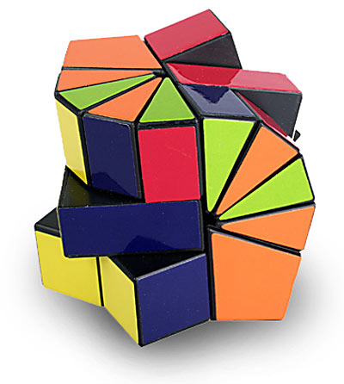 | - Bienvenido  - Anuncios  - Watch Senior Jordan: Irregular TU commands  - Video worksheet is due at the end of class. | No hay tarea
jueves  26 de febrero   | - Bienvenido  - Anuncios  - Watch Senior Jordan: TU commands + pronouns practices 1, 2, 3,  - Video worksheet is due at the end of class manana. | No hay tarea
viernes  27 de febrero   | - Bienvenidos  - Anuncios  - Distribute project rubric: Command Signs  - -You will create 3 separate signs that have an image (with color) and implements a positive/negative/irregular commands in the TU form. This is due by the end of class. | No hay tarea

LA FECHA | TAREAS – CLASE | TAREAS – CASA
lunes  23 de febrero | - Bienvendio  - Introduce Commands  - Watch Senior Jordan: Affirmative TU commands  - Turn in video notes by the end of class. | No hay tarea
martes  24 de febrero | - Bienvenido  - Anuncios  - Watch Senior Jordan: Negative TU commands  - Video worksheet is due at the end of class. | No hay tarea
miércoles  25 de febrero | - Bienvenido  - Anuncios  - Watch Senior Jordan: Irregular TU commands  - Video worksheet is due at the end of class. | No hay tarea
jueves  26 de febrero | - Bienvenido  - Anuncios  - Watch Senior Jordan: TU commands + pronouns practices 1, 2, 3,  - Video worksheet is due at the end of class manana. | No hay tarea
viernes  27 de febrero | - Bienvenidos  - Anuncios  - Distribute project rubric: Command Signs  - -You will create 3 separate signs that have an image (with color) and implements a positive/negative/irregular commands in the TU form. This is due by the end of class. | No hay tarea

